Operating Systems Insem Lab Experiments

Name: A.Srija
Roll No: 2420030062
Faculty: V. Muniraju Naidu
Experiment 1: System Call Trace and Categorization using Python

Problem Statement:

To trace and analyze the system calls generated by a Python program using the strace tool, and to classify these system calls into appropriate categories such as file management, process management, and memory management. This experiment aims to provide a deeper understanding of how user-level programs interact with the operating system kernel through system calls, and how different operations performed by a program are handled at the system level. By observing and categorizing these system calls, the internal working of the operating system and its role in executing user programs can be better understood.
ALGORITHM:
Step 1: Start
Step 2: Write a Python program to perform file operations
Step 3: Create a file named test.txt
Step 4: Write data into the file
Step 5: Close the file
Step 6: Open the file in read mode
Step 7: Read the content from the file
Step 8: Display the content on the screen
Step 9: Close the file
Step 10: Execute the program using Python
Step 11: Use strace command to trace system calls
Step 12: Observe the system calls generated
Step 13: Categorize the system calls
Step 14: Stop

Code:
# file_operations.py
# Program to demonstrate file operations for syscall tracing
def write_to_file():
try:
file = open("test.txt", "w")
file.write("Hello OS Lab\n")
file.write("System Call Trace Experiment\n")
print("Data written to file successfully.")
file.close()
except Exception as e:
print("Error while writing:", e)
def read_from_file():
try:
file = open("test.txt", "r")
content = file.read()
print("Reading data from file...")
print("File Content:\n", content)
file.close()
except Exception as e:
print("Error while reading:", e)
def main():
print("----- File Operations Started -----")
write_to_file()
read_from_file()
print("----- File Operations Completed -----")

if __name__ == "__main__":
main()

Execution Steps (Commands):

Step 1: Open the terminal in your working directory
Step 2: Create the Python file using any editor (VS Code / nano / gedit)
Step 3: Save the file as file_operations.py
Step 4: Run the Python program using the command
python3 file_operations.py
Step 5: Observe the output displayed on the screen
Step 6: Execute the program with system call tracing using the command
strace python3 file_operations.py
Step 7: Observe the system calls generated during execution
Step 8: Identify important system calls such as open, read, write, and close
Step 9: Record the relevant system calls for analysis
Step 10: Stop

CODE:

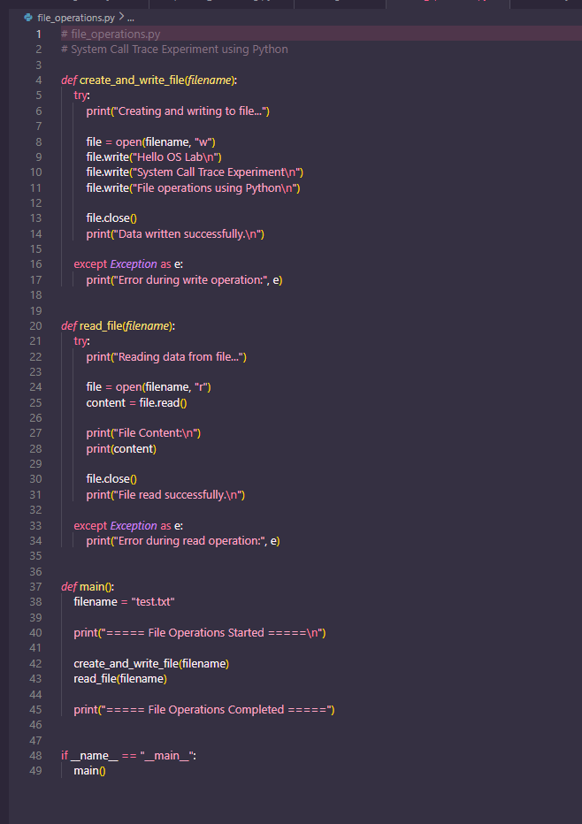

Sample Input:
Type: Predefined (Internal Input)
Data used:
Hello OS Lab
System Call Trace Experiment
File operations using Python

Sample Output:
===== File Operations Started =====
Creating and writing to file...
Data written successfully.
Reading data from file...
File Content:
Hello OS Lab
System Call Trace Experiment
File operations using Python
File read successfully.

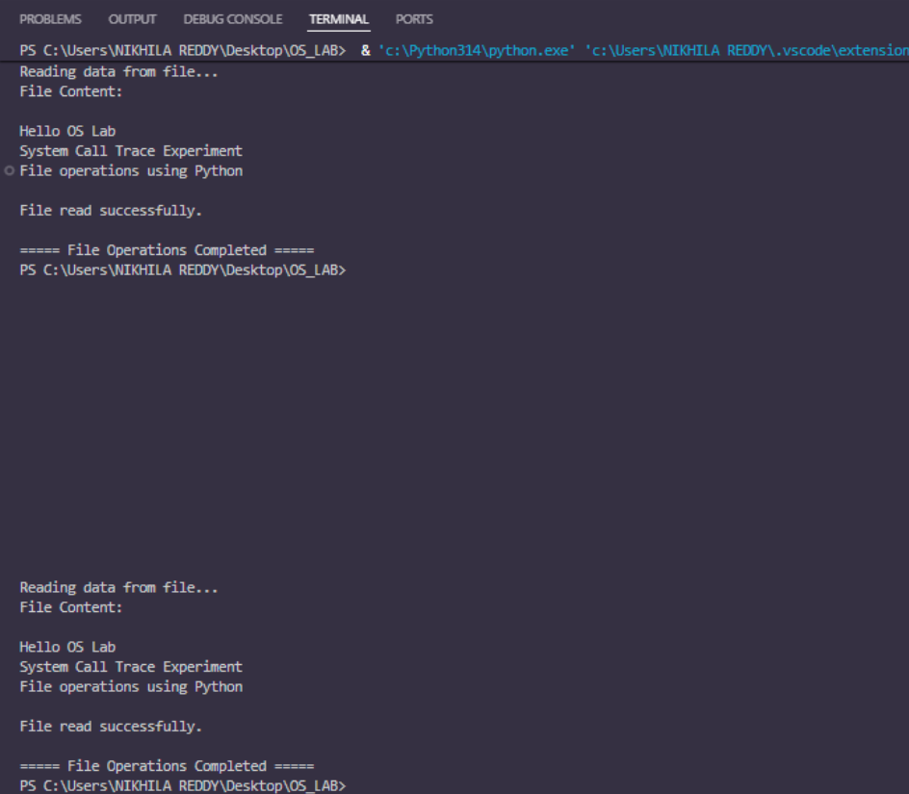
Result:
The Python program for file operations was executed successfully. The system calls generated during execution were traced using the strace tool. Relevant system calls such as open(), write(), read(), and close() were identified and categorized under file management. The output was obtained as expected, demonstrating successful interaction between the user program and the operating system.

EXPERIMENT-2: Synchronization Correctness & Deadlock Demo
Problem Statement
In multithreaded systems, multiple threads may access shared resources simultaneously. This can lead to race conditions, where the final result depends on the order of thread execution. To ensure correct behavior, synchronization mechanisms such as mutex locks or synchronized blocks are used. However, improper locking can lead to deadlocks, where two or more threads wait indefinitely for resources held by each other.
The objective of this experiment is to:
- Demonstrate a race condition
- Fix it using synchronization
- Intentionally create a deadlock
- Observe thread behavior and analyze the results

🧠 Algorithm / Procedure
Part A: Race Condition
Step 1: Create a shared variable counter
Step 2: Create two threads
Step 3: Each thread increments the counter multiple times
Step 4: Without synchronization, both threads modify the counter simultaneously
Step 5: Observe incorrect or unpredictable results

Part B: Synchronization
Step 1: Use a synchronized method or block
Step 2: Allow only one thread to access the shared variable at a time
Step 3: Execute the program again
Step 4: Verify that the counter value is correct
Part C: Deadlock Demonstration
Step 1: Create two shared lock objects
Step 2: Thread 1 locks Resource A and waits for Resource B
Step 3: Thread 2 locks Resource B and waits for Resource A
Step 4: Both threads wait indefinitely, causing deadlock
Step 5: Observe that the program stops progressing

Execution Steps (Commands)
Step 1: Open VS Code or terminal
Step 2: Create a Python file named sync_deadlock_demo.py
Step 3: Write the program code and save the file
Step 4: Open terminal in the project directory
Step 5: Execute the program using the command
python sync_deadlock_demo.py
Step 6: Enter the number of increments when prompted
Step 7: Observe the output for race condition
Step 8: Observe the corrected output after synchronization
Step 9: Observe the deadlock situation where the program stops execution
Step 10: Stop

CODE:
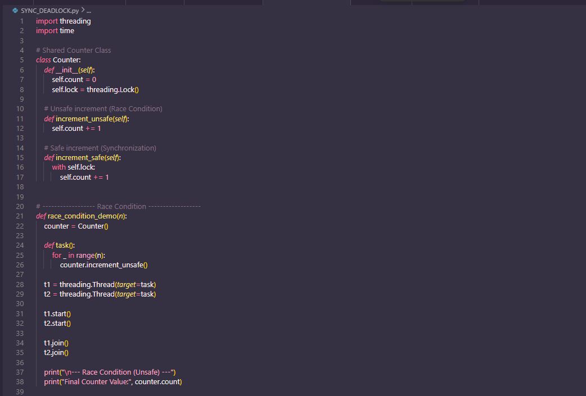
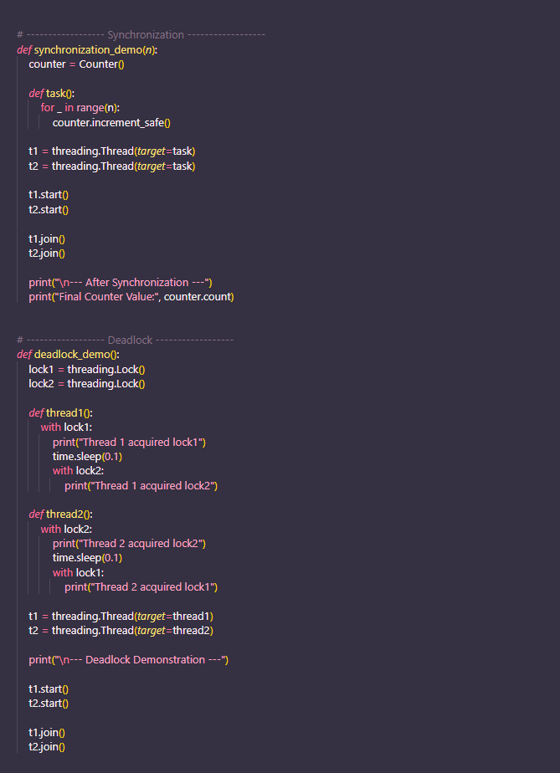

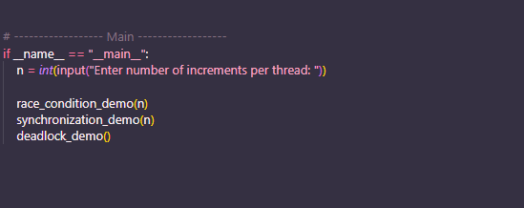

Sample Input
Enter number of increments per thread: 1000

Sample Output
--- Race Condition (Unsafe) ---
Final Counter Value: 1837 (value may vary)
--- After Synchronization ---
Final Counter Value: 2000
--- Deadlock Demonstration ---
Thread 1 acquired lock1
Thread 2 acquired lock2
(Program stops here due to deadlock)

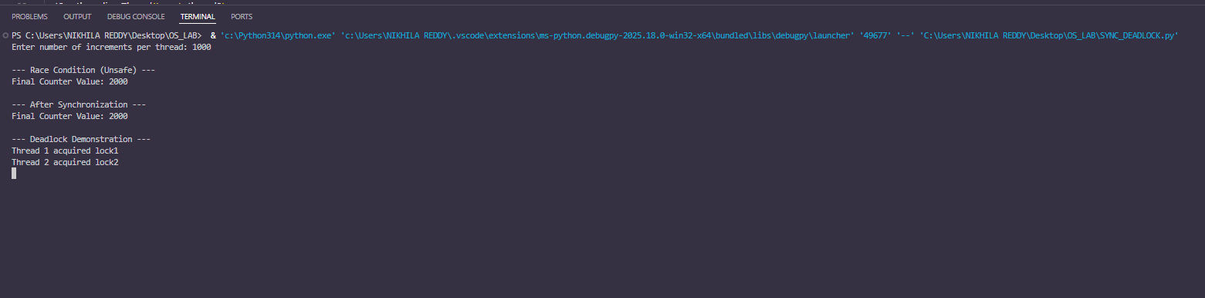

Result:
The experiment successfully demonstrated: ● A race condition scenario ● Correct synchronization using Java’s synchronized keyword ● A deadlock situation caused by improper lock ordering This illustrates the importance of proper synchronization techniques in concurrent programming

